

Semester Two Examination, 2019

Question/Answer booklet

MATHEMATICS

If required by your examination administrator, please place your student identification label in this box
METHODS
UNITS 3 AND 4

Section One:

Calculator-free

Student number: In figures

In words

Your name

Time allowed for this section
Reading time before commencing work: five minutes
Working time: fifty minutes

Materials required/recommended for this section
To be provided by the supervisor
This Question/Answer booklet
Formula sheet

To be provided by the candidate
Standard items: pens (blue/black preferred), pencils (including coloured), sharpener,
correction fluid/tape, eraser, ruler, highlighters

Special items: nil

Important note to candidates
No other items may be taken into the examination room. It is your responsibility to ensure that you do not have any unauthorised material. If you have any unauthorised material with you, hand it to the supervisor before reading any further.

Structure of this paper

Section | Number of questions available | Number of questions to be answered | Working  time (minutes) | Marks available | Percentage of examination
Section One:  Calculator-free | 8 | 8 | 50 | 52 | 35
Section Two:  Calculator-assumed | 13 | 13 | 100 | 98 | 65
 |  |  |  | Total | 100

Markers use only
Question | Maximum | Mark
1 | 4
2 | 6
3 | 7
4 | 7
5 | 7
6 | 8
7 | 6
8 | 7
S1 Total | 52
S1 Wt (×0.6731) | 35%
S2 Wt | 65%
Total | 100%

Instructions to candidates

1. The rules for the conduct of examinations are detailed in the school handbook. Sitting this examination implies that you agree to abide by these rules.

2. Write your answers in this Question/Answer booklet preferably using a blue/black pen.
Do not use erasable or gel pens.

3. You must be careful to confine your answer to the specific question asked and to follow any instructions that are specified to a particular question.

4. Show all your working clearly. Your working should be in sufficient detail to allow your answers to be checked readily and for marks to be awarded for reasoning. Incorrect answers given without supporting reasoning cannot be allocated any marks. For any question or part question worth more than two marks, valid working or justification is required to receive full marks. If you repeat any question, ensure that you cancel the answer you do not wish to have marked.

5. It is recommended that you do not use pencil, except in diagrams.

6. Supplementary pages for planning/continuing your answers to questions are provided at the end of this Question/Answer booklet. If you use these pages to continue an answer, indicate at the original answer where the answer is continued, i.e. give the page number.

7. The Formula sheet is not to be handed in with your Question/Answer booklet.
Section One: Calculator-free 35% (52 Marks)
This section has eight (8) questions. Answer all questions. Write your answers in the spaces provided.

Working time: 50 minutes.

Question 1 (4 marks)
Determine the following:

(a) $\int_{ }^{ }{\underset{ }{\overset{ }{12{(2x+1)}^{2}}}}dx$. (2 marks)

(b) $\begin{matrix}d \\ \overline{dx}\end{matrix}\cos\left(2x+1\right)$. (1 mark)

(c) $\begin{matrix}d \\ \overline{dx}\end{matrix}\int_{3}^{x}{\underset{ }{\overset{ }{(2t+1)}}}dt$. (1 mark)

Question 2 (6 marks)
Let $f(x)=\sqrt{3}\cos\left(\begin{matrix}x \\ \overline{2}\end{matrix}\right)$ and $g(x)=\sin\left(\begin{matrix}x \\ \overline{2}\end{matrix}\right)$.

The shaded region on the graph below is enclosed by $x=0,$ $y=f(x)$ and $y=g(x)$.
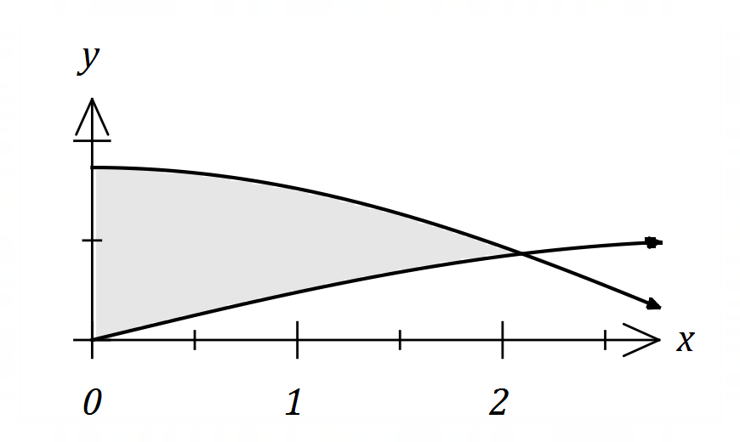

(a) Show that $f\left(\begin{matrix}2π \\ \overline{ 3 }\end{matrix}\right)=g\left(\begin{matrix}2π \\ \overline{ 3 }\end{matrix}\right)$. (2 marks)

(b) Determine the area of the shaded region. (4 marks)

Question 3 (7 marks)
(a) Write $2\log_{4}{3}-\log_{4}{6}-1$ in the form $\log_{4}{k}$. (3 marks)

(b) Solve for $x$ the equation $e^{2x-3}=9$. (2 marks)

(c) Determine $\begin{matrix}d \\ \overline{dx}\end{matrix}\left(\log_{e}\left(\begin{matrix}1 \\ \overline{x^{6}+5}\end{matrix}\right)\right)$. (2 marks)

Question 4 (7 marks)
The velocity of a small body moving in a straight line at time $t$ seconds is given by

$$v=\frac{8}{t+3} \text{m/s}, t≥0.$$

(a) Determine the velocity of the body when its acceleration is $-0.5$ m/s². (4 marks)

(b) Calculate the distance travelled by the body in the first $3$ seconds. (3 marks)

Question 5 (7 marks)
The random variable $X$ has probability density function $f\left(x\right)$ shown below, where $k$ is a positive constant.
$$f\left(x\right)=\left\{\begin{matrix}kx+\frac{1}{30} & & 0≤x≤5 \\ 0 & & \text{elsewhere}\end{matrix}\right.$$

(a) Deduce that $k=\begin{matrix}1 \\ \overline{15}\end{matrix}$. (3 marks)

(b) Determine the value of $a$ if $P\left(1<X<a\right)=\begin{matrix}3 \\ \overline{5}\end{matrix}$. (4 marks)

Question 6 (8 marks)
Let $f\left(x\right)=\left(1+x\right)e^{-3x}$.

(a) Determine the coordinates of the stationary point of the graph of $y=f(x)$ and use the second derivative test to determine its nature. (6 marks)

(b) Determine the coordinates of the point of inflection of the graph of $y=f(x)$. (2 marks)

Question 7 (6 marks)
Let $f\left(x\right)=\begin{matrix}x \\ \overline{x+1}\end{matrix}$.

(a) Determine $f(x)$ and $f(x+δx)$ when $x=70$ and $δx=5$. (1 mark)

(b) Use $f(x)$ and the increments formula to estimate the difference between $\begin{matrix}89 \\ \overline{90}\end{matrix}$ and $\begin{matrix}92 \\ \overline{93}\end{matrix}$.

(5 marks)

Question 8 (7 marks)
In a class of $21$ students, $18$ are right-handed.

(a) One student is selected at random from the class and the random variable $X$ is the number of right-handed students in the selection. Determine the mean and standard deviation of $X$. (3 marks)

(b) Two students are selected at random from the class without replacement and the random variable $Y$ is the number of right-handed students in the selection.

(i) Complete the probability distribution table below. (3 marks)

$$y$$ | $$0$$ | $$1$$ | $$2$$
$$P(Y=y)$$

(ii) Determine $E(Y)$. (1 mark)



Semester Two Examination, 2019

Question/Answer booklet

MATHEMATICS

If required by your examination administrator, please place your student identification label in this box
METHODS
UNITS 3 AND 4

Section Two:

Calculator-assumed

Student number: In figures

In words

Your name

Time allowed for this section
Reading time before commencing work: ten minutes
Working time: one hundred minutes

Materials required/recommended for this section
To be provided by the supervisor
This Question/Answer booklet
Formula sheet (retained from Section One)

To be provided by the candidate
Standard items: pens (blue/black preferred), pencils (including coloured), sharpener,
correction fluid/tape, eraser, ruler, highlighters

Special items: drawing instruments, templates, notes on two unfolded sheets of A4 paper, and up to three calculators approved for use in this examination

Important note to candidates
No other items may be taken into the examination room. It is your responsibility to ensure that you do not have any unauthorised material. If you have any unauthorised material with you, hand it to the supervisor before reading any further.

Structure of this paper

Section | Number of questions available | Number of questions to be answered | Working  time (minutes) | Marks available | Percentage of examination
Section One:  Calculator-free | 8 | 8 | 50 | 52 | 35
Section Two:  Calculator-assumed | 13 | 13 | 100 | 98 | 65
 |  |  |  | Total | 100

Markers use only
Question | Maximum | Mark
9 | 6
10 | 6
11 | 6
12 | 6
13 | 8
14 | 9
15 | 8
16 | 8
17 | 7
18 | 7
19 | 9
20 | 9
21 | 9
S2 Total | 98
S2 Wt (×0.6633) | 65%

Instructions to candidates

1. The rules for the conduct of examinations are detailed in the school handbook. Sitting this examination implies that you agree to abide by these rules.

2. Write your answers in this Question/Answer booklet preferably using a blue/black pen.
Do not use erasable or gel pens.

3. You must be careful to confine your answer to the specific question asked and to follow any instructions that are specified to a particular question.

4. Show all your working clearly. Your working should be in sufficient detail to allow your answers to be checked readily and for marks to be awarded for reasoning. Incorrect answers given without supporting reasoning cannot be allocated any marks. For any question or part question worth more than two marks, valid working or justification is required to receive full marks. If you repeat any question, ensure that you cancel the answer you do not wish to have marked.

5. It is recommended that you do not use pencil, except in diagrams.

6. Supplementary pages for planning/continuing your answers to questions are provided at the end of this Question/Answer booklet. If you use these pages to continue an answer, indicate at the original answer where the answer is continued, i.e. give the page number.

7. The Formula sheet is not to be handed in with your Question/Answer booklet.
Section Two: Calculator-assumed 65% (98 Marks)
This section has thirteen (13) questions. Answer all questions. Write your answers in the spaces provided.

Working time: 100 minutes.

Question 9 (6 marks)
The graph of $y=f(x)$, where $f(x)=5\log_{e}{(x-a)}$, has a root at $x=5$.

(a) Determine the value of the constant $a$ and hence state the equation of the asymptote of the graph. (2 marks)

(b) Determine the exact coordinates of the point on the graph where $f^{'}\left(x\right)=\begin{matrix}1 \\ 5\end{matrix}$. (3 marks)

(c) The graph of the equation $y=f(x)$ is the same shape as the graph with the equation
$y=\log_{e}{g(x)}$. State a suitable function for $g(x)$. (1 mark)

Question 10 (6 marks)
A machine is set to fill bottles with more than the stated capacity. The random variable $X$ mL is the amount it overfills bottles and has probability density function $f\left(x\right)$ shown below.

$$f\left(x\right)=\left\{\begin{matrix}\frac{\sqrt{3x-6}}{6} & & 2≤x≤5 \\ & & \\ 0 & & \text{otherwise}\end{matrix}\right.$$

(a) Determine $E(X)$. (2 marks)

(b) Determine $\operatorname{Var}{(X)}$. (2 marks)

(c) The amount another machine overfills bottles is given by $Y=1+0.25X$. Determine

(i) $E(Y)$. (1 mark)

(ii) $\operatorname{Var}{(Y)}$. (1 mark)

Question 11 (6 marks)
A water tank sprung a leak. The amount of water $W$ remaining in the tank $t$ minutes after the leak began can be modelled by the equation $W=30e^{-kt}$ kilolitres, where $k$ is a constant.

$3.5$ kL of water was lost from the tank in the first $10$ minutes.

(a) Determine the value of $k$. (2 marks)

(b) How many kilolitres of water leaked from the tank during the first $2$ hours? (2 marks)

(c) At what time, to the nearest minute, was the instantaneous rate of water loss 186 litres per minute? (2 marks)

Question 12 (6 marks)
An opinion poll found that $206$ out of $358$ people supported a policy to increase the minimum wage, from which a $99\%$ approximate confidence interval for the population proportion was calculated to be
$$(0.508, 0.643)$$

(a) Show how this interval was calculated. (4 marks)

(b) If $18$ similar opinion polls were taken and each time a $99\%$ confidence interval calculated, determine the probability that all $18$ intervals contain the true population proportion.
(2 marks)

Question 13 (8 marks)
The table below shows the probability distribution for a random variable $X$.

$$x$$ | $$0$$ | $$1$$ | $$2$$ | $$3$$
$$P(X=x)$$ | $$2k^{2}+2k$$ | $$k^{2}$$ | $$2k^{2}+k$$ | $$k$$

(a) Determine the value of the constant $k$. (2 marks)

(b) Determine $E\left(X\right)$ and $\operatorname{Var}{(X)}$. (3 marks)

(c) Given that $E\left(aX+b\right)=5$ and $\operatorname{Var}\left(aX+b\right)=38$, determine all possible values of the constants $a$ and $b$. (3 marks)

Question 14 (9 marks)
The time taken to answer a customer call at a large business can be modelled by the continuous random variable $T$ that is uniformly distributed between $5$ and $40$ seconds.

(a) Sketch a diagram of the associated probability density function for $T$. (3 marks)

(b) Determine $P\left(T<32 \right| T>11)$. (2 marks)

(c) A simulation involves taking a random sample from the uniform distribution, recording the time and repeating a total of $300$ times. The times are then grouped into $5$ equal width classes, from which a frequency histogram is constructed.

(i) Sketch a likely histogram on the axes below. (3 marks)

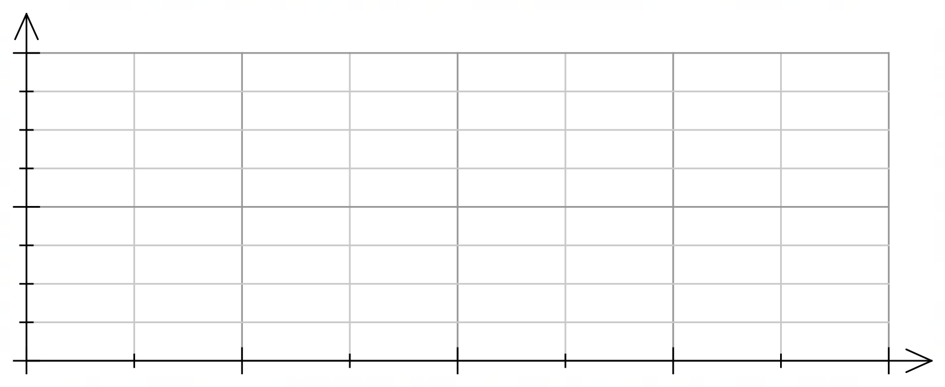

(ii) Briefly explain how your sketch would change if the simulation was repeated a second time. (1 mark)

Question 15 (8 marks)
It is known that $80\%$ of a large population of animals carry microfilariae in their blood (are carriers). A student must simulate selecting animals that either are or are not carriers.

(a) Describe a method that the student could use. (2 marks)

(b) The random variable $X$ is the number of animals in a random sample of size $200$ that are carriers. Describe the distribution of $X$ and determine $E(X)$. (2 marks)

$225$ students carry out the simulation so that they each have a sample of size $200$. Then each student calculates $\hat{p}$, the proportion of animals in their sample that are carriers. The distribution of these $225$ values of $\hat{p}$ will be approximately normal.

(c) Determine the parameters of the normal distribution the $225$ values of $\hat{p}$ will approximate. (2 marks)

(d) Briefly describe how the closeness of the normal approximation would change if

(i) the sample size was larger. (1 mark)

(ii) the percentage of animals that are carriers was higher. (1 mark)

Question 16 (8 marks)
The graph of $y=f\left(x\right)$ is shown below.

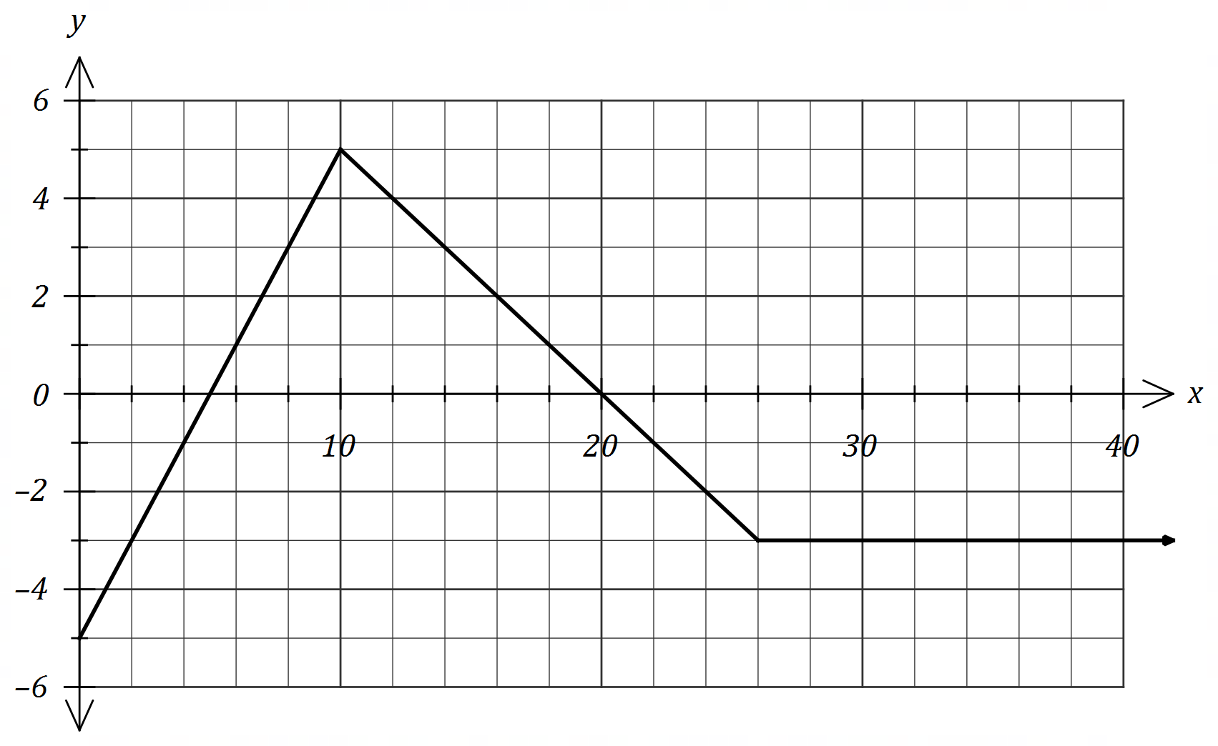

(a) Determine $\int_{3}^{9}{\underset{ }{\overset{ }{f(x)}}}dx$. (2 marks)

Let $A\left(x\right)=\int_{0}^{x}{\underset{ }{\overset{ }{f(t)}}}dt$.

(b) Determine

(i) $A(5)$. (1 mark)

(ii) $A'(5)$. (1 mark)

(c) Determine the coordinates of the maximum of the graph of $y=A(x)$. (2 marks)

(d) Determine the root of the graph of $y=A(x)$ for $x>10$. (2 marks)

Question 17 (7 marks)
A citrus farm grows Verna lemons. Their weights are normally distributed with a mean of $153$ g and a standard deviation of $9.4$ g.

(a) Determine the probability that

(i) a randomly chosen lemon has a weight less than $150$ g. (1 mark)

(ii) in a random sample of $10$ lemons, exactly $1$ has a weight less than $150$ g.
(2 marks)

The farm classifies their lemons by size, so that the ratio of the number of small to medium to large lemons is $2 :4 :5$.

(b) Determine the upper and lower bounds for the weight of a medium sized lemon. (2 marks)

(c) Determine the probability that when lemons are picked at random, the first medium lemon is chosen on the $6$^{th} pick. (2 marks)

Question 18 (7 marks)
When seen from above, an evaporation tank of area $480$ m² has the shape of rectangle $EDGH$ and semicircle $EFG$ of radius $r$.
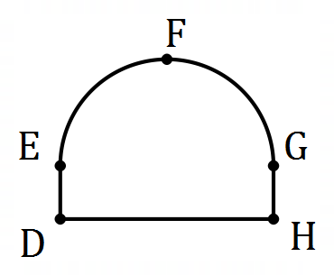
(a) If length $DE=x$, express $x$ in terms of $r$ and hence show that the perimeter, $P$ m, of the tank is given by (3 marks)
$$P=\frac{480}{r}+2r+\frac{πr}{2}$$

(b) Use a calculus method to determine the minimum perimeter of the tank. (4 marks)

Question 19 (9 marks)
A particle moves along the $x$-axis with initial position $x\left(0\right)=1.5$ m and velocity $v\left(0\right)=-2.4$ m/s.

The acceleration of the particle after $t$ seconds is given by $a(t)=m-0.4t$ m/s².

Between $t=2$ and $t=5$ the particle undergoes a change in displacement of $69$ m.

(a) Determine the value of the constant $m$. (4 marks)

(b) Determine

(i) the maximum velocity of the particle. (2 marks)

(ii) the distance of the particle from the origin after $3$ seconds. (3 marks)

Question 20 (9 marks)
Researchers in a large city wish to determine a $95\%$ confidence interval for $p$, the proportion of citizens who had used the city library at least once during the previous year. The margin of error of the interval is to be no more than $6\%$.

(a) If the researchers had no reliable estimate for $p$, determine the sample size they should take, noting all assumptions made. (5 marks)

(b) The researchers were given access to data from a random sample of $165$ citizens collected a few years earlier. Of these, $36$ had used the city library at least once during the previous year.

(i) Determine the margin of error for a $95\%$ confidence interval for $p$ based on this sample. (2 marks)

(ii) The researchers used this data to decrease the sample size calculated in part (a). By how much did the sample size decrease? (2 marks)

Question 21 (9 marks)
The population of a species $P$ can be modelled by the equation $P=ab^{t}$, where $a$ and $b$ are constants and $t$ is the number of years since the population was first recorded. The graph below shows the linear relationship between $t$ and $\log_{10}{P}$ for the population over the past $60$ years and passes through the points $(0, 3)$ and $(58, 3.5)$.

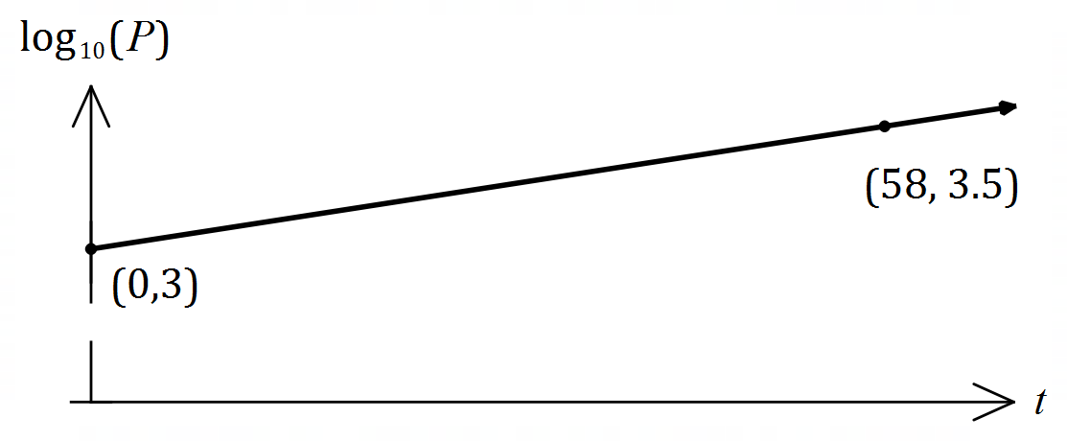

(a) Write an equation relating $\log_{10}{P}$ and $t$. (2 marks)

(b) Determine the value of $a$ and the value of $b$. (3 marks)

(c) Interpret the value of $a$ and the value of $b$ in the context of this model. (2 marks)

(d) Use the model to determine

(i) the population when $t=45$. (1 mark)

(ii) the number of years for the population to reach $10 000$. (1 mark)



Semester Two Examination, 2019

Question/Answer booklet

MATHEMATICS

SOLUTIONS
METHODS
UNITS 3 AND 4

Section One:

Calculator-free

Student number: In figures

In words

Your name

Time allowed for this section
Reading time before commencing work: five minutes
Working time: fifty minutes

Materials required/recommended for this section
To be provided by the supervisor
This Question/Answer booklet
Formula sheet

To be provided by the candidate
Standard items: pens (blue/black preferred), pencils (including coloured), sharpener,
correction fluid/tape, eraser, ruler, highlighters

Special items: nil

Important note to candidates
No other items may be taken into the examination room. It is your responsibility to ensure that you do not have any unauthorised material. If you have any unauthorised material with you, hand it to the supervisor before reading any further.

Structure of this paper

Section | Number of questions available | Number of questions to be answered | Working  time (minutes) | Marks available | Percentage of examination
Section One:  Calculator-free | 8 | 8 | 50 | 52 | 35
Section Two:  Calculator-assumed | 13 | 13 | 100 | 98 | 65
 |  |  |  | Total | 100

Instructions to candidates

1. The rules for the conduct of examinations are detailed in the school handbook. Sitting this examination implies that you agree to abide by these rules.

2. Write your answers in this Question/Answer booklet preferably using a blue/black pen.
Do not use erasable or gel pens.

3. You must be careful to confine your answer to the specific question asked and to follow any instructions that are specified to a particular question.

4. Show all your working clearly. Your working should be in sufficient detail to allow your answers to be checked readily and for marks to be awarded for reasoning. Incorrect answers given without supporting reasoning cannot be allocated any marks. For any question or part question worth more than two marks, valid working or justification is required to receive full marks. If you repeat any question, ensure that you cancel the answer you do not wish to have marked.

5. It is recommended that you do not use pencil, except in diagrams.

6. Supplementary pages for planning/continuing your answers to questions are provided at the end of this Question/Answer booklet. If you use these pages to continue an answer, indicate at the original answer where the answer is continued, i.e. give the page number.

7. The Formula sheet is not to be handed in with your Question/Answer booklet.
Section One: Calculator-free 35% (52 Marks)
This section has eight (8) questions. Answer all questions. Write your answers in the spaces provided.

Working time: 50 minutes.

Question 1 (4 marks)
Determine the following:

(a) $\int_{ }^{ }{\underset{ }{\overset{ }{12{(2x+1)}^{2}}}}dx$. (2 marks)
Solution
$$\frac{12}{2×3}{\left(2x+1\right)}^{3}=2{\left(2x+1\right)}^{3}+c$$

Specific behaviours
integrates correctly
✓ includes constant

(b) $\begin{matrix}d \\ \overline{dx}\end{matrix}\cos\left(2x+1\right)$. (1 mark)
Solution
$$-2\sin\left(2x+1\right)$$

Specific behaviours
correct derivative

(c) $\begin{matrix}d \\ \overline{dx}\end{matrix}\int_{3}^{x}{\underset{ }{\overset{ }{(2t+1)}}}dt$. (1 mark)
Solution
$$2x+1$$

Specific behaviours
correct use of fundamental theorem

Question 2 (6 marks)
Let $f(x)=\sqrt{3}\cos\left(\begin{matrix}x \\ \overline{2}\end{matrix}\right)$ and $g(x)=\sin\left(\begin{matrix}x \\ \overline{2}\end{matrix}\right)$.

The shaded region on the graph below is enclosed by $x=0,$ $y=f(x)$ and $y=g(x)$.


(a) Show that $f\left(\begin{matrix}2π \\ \overline{ 3 }\end{matrix}\right)=g\left(\begin{matrix}2π \\ \overline{ 3 }\end{matrix}\right)$. (2 marks)
Solution
$$f\left(\begin{matrix}2π \\ \overline{ 3 }\end{matrix}\right)=\sqrt{3}\cos\left(\begin{matrix}π \\ \overline{ 3 }\end{matrix}\right)=\sqrt{3}×\frac{1}{2}=\frac{\sqrt{3}}{2} \\ g\left(\begin{matrix}2π \\ \overline{ 3 }\end{matrix}\right)=\sin\left(\begin{matrix}π \\ \overline{ 3 }\end{matrix}\right)=\frac{\sqrt{3}}{2}$$

Hence $f\left(\begin{matrix}2π \\ \overline{ 3 }\end{matrix}\right)=g\left(\begin{matrix}2π \\ \overline{ 3 }\end{matrix}\right)$.

Specific behaviours
evaluates $f\left(x\right)$
✓ evaluates $g\left(x\right)$, stating same as $f(x)$

(b) Determine the area of the shaded region. (4 marks)
Solution
$$\int_{0}^{\begin{matrix}2π \\ \overline{ 3 }\end{matrix}}{\sqrt{3}\cos\left(\begin{matrix}x \\ \overline{2}\end{matrix}\right)}-\sin\left(\begin{matrix}x \\ \overline{2}\end{matrix}\right)dx$$
$$={\left[2\sqrt{3}sin\left(\begin{matrix}x \\ \overline{2}\end{matrix}\right)+2\cos\left(\begin{matrix}x \\ \overline{2}\end{matrix}\right)\right]}_{0}^{\begin{matrix}2π \\ \overline{ 3 }\end{matrix}} \\ =\left[2\sqrt{3}sin\left(\begin{matrix}π \\ \overline{3}\end{matrix}\right)+2\cos\left(\begin{matrix}π \\ \overline{3}\end{matrix}\right)\right]-\left[2\sqrt{3}sin\left(0\right)+2\cos\left(0\right)\right] \\ =\left(2\sqrt{3}×\frac{\sqrt{3}}{2}+2×\frac{1}{2}\right)-2 \\ =3+1-2=2 \text{sq units}$$

Specific behaviours
writes correct integral
✓ integrates correctly
✓ substitutes correctly
✓ correct area

Question 3 (7 marks)
(a) Write $2\log_{4}{3}-\log_{4}{6}-1$ in the form $\log_{4}{k}$. (3 marks)
Solution
$$2\log_{4}{3}-\log_{4}{6}-1=2\log_{4}{3}-\log_{4}{6}-\log_{4}{4} \\ =\log_{4}{3^{2}}-\left(\log_{4}{6}+\log_{4}{4}\right) \\ =\log_{4}\left(\frac{9}{6×4}\right) \\ =\log_{4}\left(\frac{3}{8}\right)$$

Specific behaviours
uses $\log_{a}{a}=1$
✓ uses $x\log_{a}{y}={\log_{a}{y}}^{x}$
✓ uses $\log_{a}{x}±\log_{a}{y}$

(b) Solve for $x$ the equation $e^{2x-3}=9$. (2 marks)
Solution
$$2x-3=\ln{9} \\ 2x=2\ln{(3)}+3 \\ x=\ln{(3)}+1.5$$

Specific behaviours
expresses using natural log
✓ simplifies

(c) Determine $\begin{matrix}d \\ \overline{dx}\end{matrix}\left(\log_{e}\left(\begin{matrix}1 \\ \overline{x^{6}+5}\end{matrix}\right)\right)$. (2 marks)
Solution
$$\log_{e}\left(\begin{matrix}1 \\ \overline{x^{6}+5}\end{matrix}\right)=-\ln\left(x^{6}+5\right)$$

$$\frac{d}{dx}\left(-\ln\left(x^{6}+5\right)\right)=-\frac{6x^{5}}{x^{6}+5}$$

Specific behaviours
uses log law
✓ correct derivative

Question 4 (7 marks)
The velocity of a small body moving in a straight line at time $t$ seconds is given by

$$v=\frac{8}{t+3} \text{m/s}, t≥0.$$

(a) Determine the velocity of the body when its acceleration is $-0.5$ m/s². (4 marks)
Solution
$$\frac{dv}{dt}=\frac{d}{dt}\left({\left(t+3\right)}^{-1}\right) \\ =-8{\left(t+3\right)}^{-2}$$

$$-\frac{1}{2}=-\frac{-8}{{\left(t+3\right)}^{2}} \\ {\left(t+3\right)}^{2}=16 \\ t=-3±4 \\ t=1$$

$$v\left(1\right)=8÷4=2 \text{m/s}$$

Specific behaviours
✓ correctly differentiates
✓ equates to required value and simplifies
✓ indicates time
✓ correct velocity

(b) Calculate the distance travelled by the body in the first $3$ seconds. (3 marks)
Solution
$$\int_{0}^{3}{\frac{8}{t+3}}dt={\left[8\ln{(t+3)}\right]}_{0}^{3} \\ =8(\ln{6}-\ln{3}) \\ =8\ln{2} \text{m}$$

Specific behaviours
writes definite integral
✓ correct antiderivative
✓ substitutes bounds and simplifies

Question 5 (7 marks)
The random variable $X$ has probability density function $f\left(x\right)$ shown below, where $k$ is a positive constant.
$$f\left(x\right)=\left\{\begin{matrix}kx+\frac{1}{30} & & 0≤x≤5 \\ 0 & & \text{elsewhere}\end{matrix}\right.$$

(a) Deduce that $k=\begin{matrix}1 \\ \overline{15}\end{matrix}$. (3 marks)
Solution
$$\int_{0}^{5}{kx+\frac{1}{30}}dx={\left[\frac{kx^{2}}{2}+\frac{x}{30}\right]}_{0}^{5} \\ =\frac{25k}{2}+\frac{1}{6}$$

$$\frac{25k}{2}+\frac{1}{6}=1 \\ 25k=\frac{5}{3}⇒k=\frac{1}{15}$$

Specific behaviours
integrates $f(x)$
✓ evaluates definite integral
✓ equates to $1$ and shows steps to solve for $k$

(b) Determine the value of $a$ if $P\left(1<X<a\right)=\begin{matrix}3 \\ \overline{5}\end{matrix}$. (4 marks)
Solution
$$\int_{1}^{a}{\frac{x}{15}+\frac{1}{30}}dx={\left[\frac{x^{2}}{30}+\frac{x}{30}\right]}_{1}^{a} \\ =\frac{1}{30}\left(a^{2}+a\right)-\frac{1}{15}$$

$$\frac{1}{30}\left(a^{2}+a\right)-\frac{1}{15}=\frac{3}{5} \\ a^{2}+a-20=0 \\ \left(a+5\right)\left(a-4\right)=0 \\ a=4$$

Specific behaviours
integrates $f(x)$
✓ evaluates definite integral
✓ equates to probability and simplifies quadratic
✓ factorises and states the only valid value of $a$

Question 6 (8 marks)
Let $f\left(x\right)=\left(1+x\right)e^{-3x}$.

(a) Determine the coordinates of the stationary point of the graph of $y=f(x)$ and use the second derivative test to determine its nature. (6 marks)

Solution
$$f^{'}\left(x\right)=e^{-3x}-3(1+x)e^{-3x}$$

$$f^{'}\left(x\right)=0⇒\left(-3x-2\right)e^{-3x}=0⇒x=-\frac{2}{3}, y=\frac{e^{2}}{3}$$

$$f^{''}\left(x\right)=-3e^{-3x}+3\left(-3x-2\right)e^{-3x} \\ =(9x+3)e^{-3x}$$

$$f^{''}\left(-\frac{2}{3}\right)=-3e^{2}⇒\text{max}$$

Stationary point is at $\left(-\frac{2}{3},\frac{e^{2}}{3}\right)$ and is a maximum.

Specific behaviours
correct $f'(x)$
✓ equates $f'(x)$ to zero and obtains $x$-coordinate
✓ obtains $y$-coordinate
✓ obtains $f''(x)$
✓ indicates sign of $f''(x)$ at point
✓ coordinates of point and nature

(b) Determine the coordinates of the point of inflection of the graph of $y=f(x)$. (2 marks)
Solution
$$\left(9x+3\right)e^{-3x}=0⇒x=-\frac{1}{3}$$

$$f\left(-\frac{1}{3}\right)=\frac{2e}{3}$$

Point of inflection at $\left(-\frac{1}{3},\frac{2e}{3}\right)$

Specific behaviours
solves $f^{''}\left(x\right)=0$
✓ coordinates

Question 7 (6 marks)
Let $f\left(x\right)=\begin{matrix}x \\ \overline{x+1}\end{matrix}$.

(a) Determine $f(x)$ and $f(x+δx)$ when $x=70$ and $δx=5$. (1 mark)
Solution
$$f\left(70\right)=\frac{70}{71}, f\left(75\right)=\frac{75}{76}$$

Specific behaviours
✓ both correct fractions

(b) Use $f(x)$ and the increments formula to estimate the difference between $\begin{matrix}89 \\ \overline{90}\end{matrix}$ and $\begin{matrix}92 \\ \overline{93}\end{matrix}$.
(5 marks)
Solution
$$f^{'}\left(x\right)=\frac{1\left(x+1\right)-x\left(1\right)}{{\left(x+1\right)}^{2}} \\ =\frac{1}{{\left(x+1\right)}^{2}}$$

Find $δy$ when $x=89$ and $δx=3$.

$$δy≈f^{'}\left(x\right).δx \\ ≈\frac{1}{{\left(x+1\right)}^{2}}×δx \\ ≈\frac{3}{{90}^{2}}≈\frac{1}{2700}$$

Difference is approximately $\begin{matrix}1 \\ \overline{2700}\end{matrix}$.

Specific behaviours
✓ use of quotient rule for $f'(x)$
✓ correct $f'(x)$
indicates values of $x$ and $δx$
✓ uses increments formula
✓ substitutes, simplifies and states difference

Question 8 (7 marks)
In a class of $21$ students, $18$ are right-handed.

(a) One student is selected at random from the class and the random variable $X$ is the number of right-handed students in the selection. Determine the mean and standard deviation of $X$. (3 marks)
Solution
$$E\left(X\right)=p=\frac{18}{21}=\frac{6}{7}$$

$$\operatorname{Var}\left(X\right)=p\left(1-p\right)=\frac{6}{7}×\frac{1}{7}=\frac{6}{49}$$

Standard deviation $=\sqrt{\frac{6}{49}}=\frac{\sqrt{6}}{7}$

Specific behaviours
mean
✓ variance
✓ standard deviation

(b) Two students are selected at random from the class without replacement and the random variable $Y$ is the number of right-handed students in the selection.

(i) Complete the probability distribution table below. (3 marks)

$$y$$ | $$0$$ | $$1$$ | $$2$$
$$P(Y=y)$$ | $$1/70$$ | $$18/70$$ | $$51/70$$
Solution
$$P\left(Y=2\right)=\frac{18}{21}×\frac{17}{20}=\frac{6}{7}×\frac{17}{20}=\frac{3}{7}×\frac{17}{10}=\frac{51}{70}$$
$$P\left(Y=0\right)=\frac{3}{21}×\frac{2}{20}=\frac{1}{7}×\frac{1}{10}=\frac{1}{70}$$
$$P\left(Y=1\right)=1-\frac{51}{70}-\frac{1}{70}=\frac{18}{70}$$

Specific behaviours
✓✓ each correct probability

(ii) Determine $E(Y)$. (1 mark)

Solution
$$E\left(Y\right)=0+\frac{18}{70}+\frac{2\left(51\right)}{70}=\frac{120}{70}=\frac{12}{7}$$

Specific behaviours
correct value



Semester Two Examination, 2019

Question/Answer booklet

MATHEMATICS

SOLUTIONS
METHODS
UNITS 3 AND 4

Section Two:

Calculator-assumed

Student number: In figures

In words

Your name

Time allowed for this section
Reading time before commencing work: ten minutes
Working time: one hundred minutes

Materials required/recommended for this section
To be provided by the supervisor
This Question/Answer booklet
Formula sheet (retained from Section One)

To be provided by the candidate
Standard items: pens (blue/black preferred), pencils (including coloured), sharpener,
correction fluid/tape, eraser, ruler, highlighters

Special items: drawing instruments, templates, notes on two unfolded sheets of A4 paper, and up to three calculators approved for use in this examination

Important note to candidates
No other items may be taken into the examination room. It is your responsibility to ensure that you do not have any unauthorised material. If you have any unauthorised material with you, hand it to the supervisor before reading any further.

Structure of this paper

Section | Number of questions available | Number of questions to be answered | Working  time (minutes) | Marks available | Percentage of examination
Section One:  Calculator-free | 8 | 8 | 50 | 52 | 35
Section Two:  Calculator-assumed | 13 | 13 | 100 | 98 | 65
 |  |  |  | Total | 100

Instructions to candidates

1. The rules for the conduct of examinations are detailed in the school handbook. Sitting this examination implies that you agree to abide by these rules.

2. Write your answers in this Question/Answer booklet preferably using a blue/black pen.
Do not use erasable or gel pens.

3. You must be careful to confine your answer to the specific question asked and to follow any instructions that are specified to a particular question.

4. Show all your working clearly. Your working should be in sufficient detail to allow your answers to be checked readily and for marks to be awarded for reasoning. Incorrect answers given without supporting reasoning cannot be allocated any marks. For any question or part question worth more than two marks, valid working or justification is required to receive full marks. If you repeat any question, ensure that you cancel the answer you do not wish to have marked.

5. It is recommended that you do not use pencil, except in diagrams.

6. Supplementary pages for planning/continuing your answers to questions are provided at the end of this Question/Answer booklet. If you use these pages to continue an answer, indicate at the original answer where the answer is continued, i.e. give the page number.

7. The Formula sheet is not to be handed in with your Question/Answer booklet.
Section Two: Calculator-assumed 65% (98 Marks)
This section has thirteen (13) questions. Answer all questions. Write your answers in the spaces provided.

Working time: 100 minutes.

Question 9 (6 marks)
The graph of $y=f(x)$, where $f(x)=5\log_{e}{(x-a)}$, has a root at $x=5$.

(a) Determine the value of the constant $a$ and hence state the equation of the asymptote of the graph. (2 marks)
Solution
$$x-a=1⇒a=5-1=4$$

Asymptote is $x=4$.

Specific behaviours
determines value of $a$
✓ equation of asymptote

(b) Determine the exact coordinates of the point on the graph where $f^{'}\left(x\right)=\begin{matrix}1 \\ 5\end{matrix}$. (3 marks)
Solution
$$f^{'}\left(x\right)=\frac{5}{x-4}$$

$$\frac{5}{x-4}=\frac{1}{5}⇒x=29$$

$$y=5\ln{(29-4)}=5\ln{25}=5\ln{5^{2}}=10\ln{5}$$

At $(29, 10\ln{5})$.

Specific behaviours
indicates $f^{'}\left(x\right)$
✓ solves for $x$
✓ exact coordinates

(c) The graph of the equation $y=f(x)$ is the same shape as the graph with the equation
$y=\log_{e}{g(x)}$. State a suitable function for $g(x)$. (1 mark)
Solution
$$g\left(x\right)={\left(x-4\right)}^{5}$$

Specific behaviours
correct function (accept translations)

Question 10 (6 marks)
A machine is set to fill bottles with more than the stated capacity. The random variable $X$ mL is the amount it overfills bottles and has probability density function $f\left(x\right)$ shown below.

$$f\left(x\right)=\left\{\begin{matrix}\frac{\sqrt{3x-6}}{6} & & 2≤x≤5 \\ & & \\ 0 & & \text{otherwise}\end{matrix}\right.$$

(a) Determine $E(X)$. (2 marks)
Solution
$$\int_{2}^{5}{x∙f\left(x\right)}dx=\frac{19}{5}=3.8 \text{mL}$$

Specific behaviours
correct integral
✓ correct mean

(b) Determine $\operatorname{Var}{(X)}$. (2 marks)
Solution
$$\int_{2}^{5}{{\left(x-\frac{19}{5}\right)}^{2}∙f\left(x\right)}dx=\frac{108}{175}≈0.6171 {\text{mL}}^{2}$$

Specific behaviours
correct integral
✓ correct variance

(c) The amount another machine overfills bottles is given by $Y=1+0.25X$. Determine

(i) $E(Y)$. (1 mark)
Solution
$$1+0.25\left(\frac{19}{5}\right)=\frac{39}{20}=1.95 \text{mL}$$

Specific behaviours
correct mean

(ii) $\operatorname{Var}{(Y)}$. (1 mark)
Solution
$${\left(0.25\right)}^{2}×\frac{108}{175}=\frac{27}{700}≈0.0386 {\text{mL}}^{2}$$

Specific behaviours
correct variance

Question 11 (6 marks)
A water tank sprung a leak. The amount of water $W$ remaining in the tank $t$ minutes after the leak began can be modelled by the equation $W=30e^{-kt}$ kilolitres, where $k$ is a constant.

$3.5$ kL of water was lost from the tank in the first $10$ minutes.

(a) Determine the value of $k$. (2 marks)
Solution
$$30-3.5=30e^{-10k}$$

$$k=0.0124$$

Specific behaviours
substitutes values into equation
✓ solves for $k$

(b) How many kilolitres of water leaked from the tank during the first $2$ hours? (2 marks)
Solution
$$W\left(120\right)=30e^{-0.0124\left(120\right)}$$
$$=6.77$$

$30-6.77=23.23$ kL leaked.

Specific behaviours
amount remaining
✓ amount leaked

(c) At what time, to the nearest minute, was the instantaneous rate of water loss 186 litres per minute? (2 marks)
Solution
$$\frac{dW}{dt}=-0.186=-0.0124W$$
$$W=15$$

$$15=30e^{-0.0124t} \\ t=55.9≈56 \text{minutes}$$

Specific behaviours
calculates amount of water
✓ solves for $t$

Question 12 (6 marks)
An opinion poll found that $206$ out of $358$ people supported a policy to increase the minimum wage, from which a $99\%$ approximate confidence interval for the population proportion was calculated to be
$$(0.508, 0.643)$$

(a) Show how this interval was calculated. (4 marks)
Solution
$$\hat{p}=\frac{206}{358}≈0.5754$$

$$σ_{\hat{p}}=\sqrt{\frac{\left(0.5754\right)\left(1-0.5754\right)}{358}}≈0.0261$$

$$z_{0.99}≈2.576 \\ E=2.576×0.0261≈0.0673$$

$$0.5754±0.0673=\left(0.5081, 0.6427\right)≈(0.508, 0.643)$$

Specific behaviours
indicates proportion
✓ indicates standard deviation
✓ uses $z$-score for $95\%$ to determine margin of error
✓ uses margin of error to obtain interval

(b) If $18$ similar opinion polls were taken and each time a $99\%$ confidence interval calculated, determine the probability that all $18$ intervals contain the true population proportion.
(2 marks)
Solution
Let the rv $X$ be the # of intervals containing the true proportion, then $X\sim B\left(18, 0.99\right)$

$$P\left(X=18\right)=0.8345$$

Specific behaviours
indicates distribution with parameters
✓ correct probability

Question 13 (8 marks)
The table below shows the probability distribution for a random variable $X$.

$$x$$ | $$0$$ | $$1$$ | $$2$$ | $$3$$
$$P(X=x)$$ | $$2k^{2}+2k$$ | $$k^{2}$$ | $$2k^{2}+k$$ | $$k$$

(a) Determine the value of the constant $k$. (2 marks)
Solution
$$2k^{2}+2k+k^{2}+2k^{2}+k+k=1$$
$$5k^{2}+4k-1=0$$
$$\left(5k-1\right)\left(k+1\right)=0⇒k=\frac{1}{5}$$

Specific behaviours
sums probabilities to $1$
✓ solves equation for $k$

(b) Determine $E\left(X\right)$ and $\operatorname{Var}{(X)}$. (3 marks)
Solution
$$P\left(X=0\right)=\frac{12}{25}, P\left(X=1\right)=\frac{1}{25}, P\left(X=2\right)=\frac{7}{25}, P\left(X=3\right)=\frac{5}{25},$$

$$E\left(X\right)=\frac{6}{5}=1.2, \operatorname{Var}\left(X\right)=\frac{38}{25}=1.52$$

Specific behaviours
✓ evaluates probabilities
✓ correct mean
✓ correct variance

(c) Given that $E\left(aX+b\right)=5$ and $\operatorname{Var}\left(aX+b\right)=38$, determine all possible values of the constants $a$ and $b$. (3 marks)
Solution
Using variance: $\frac{38}{25}×a^{2}=38⇒a=±5$

Using mean: $5\left(\frac{6}{5}\right)+b=5⇒b=-1$ or $-5\left(\frac{6}{5}\right)+b=5⇒b=11$

$$\left\{a=5, b=-1\right\}\text{ or }\left\{a=-5, b=11\right\}$$

Specific behaviours
one value for $a$
✓ one value for $b$
✓ all possible solutions

Question 14 (9 marks)
The time taken to answer a customer call at a large business can be modelled by the continuous random variable $T$ that is uniformly distributed between $5$ and $40$ seconds.

(a) Sketch a diagram of the associated probability density function for $T$. (3 marks)
Solution
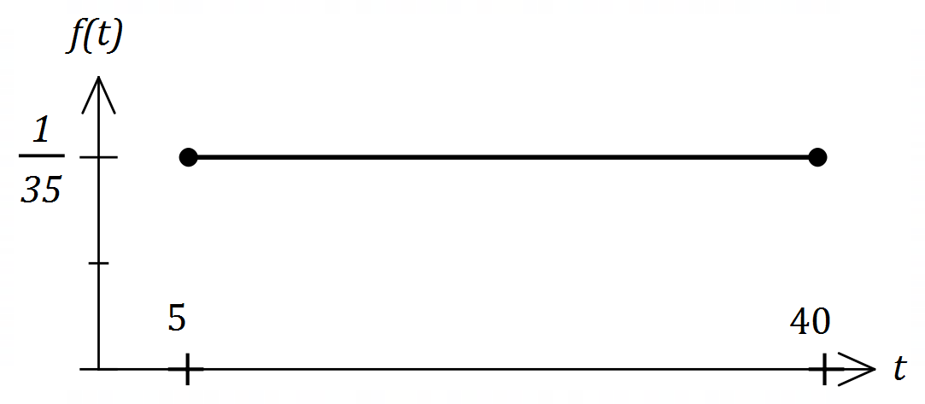
Specific behaviours
indicates scale on $y$-axis
✓ indicates endpoints on $x$-axis
✓ horizontal line segment

(b) Determine $P\left(T<32 \right| T>11)$. (2 marks)
Solution
$$P=\frac{P(11<T<32)}{P(T>11)}=\frac{32-11}{40-11}=\frac{21}{29}$$

Specific behaviours
indicates correct method
✓ correct probability

(c) A simulation involves taking a random sample from the uniform distribution, recording the time and repeating a total of $300$ times. The times are then grouped into $5$ equal width classes, from which a frequency histogram is constructed.

(i) Sketch a likely histogram on the axes below. (3 marks)

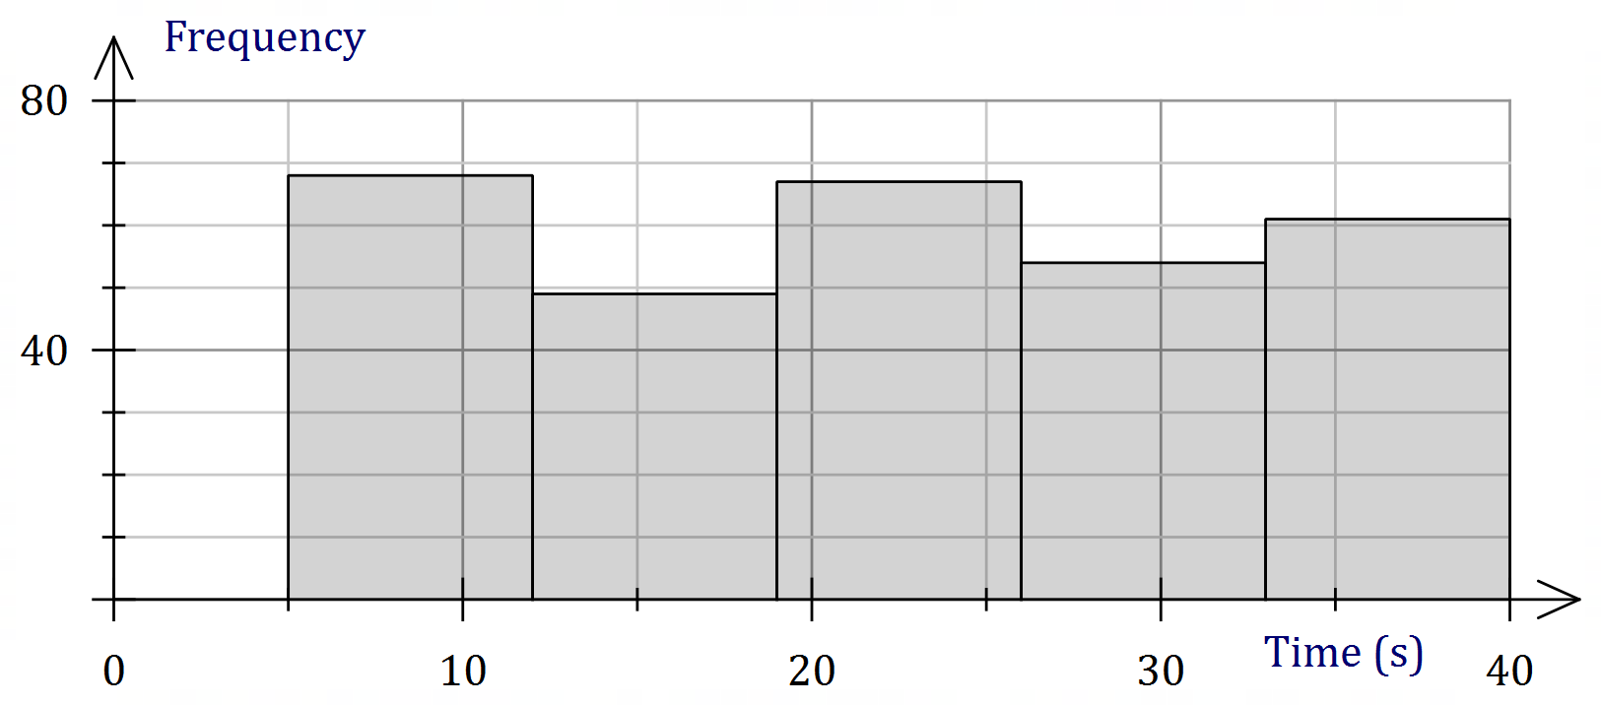
Solution
See graph.
Specific behaviours
horizontal scale and intervals
✓ vertical scale
✓ columns with slight height variations

(ii) Briefly explain how your sketch would change if the simulation was repeated a second time. (1 mark)
Solution
Would expect about the same again, but with slightly different frequencies in each class.
Specific behaviours
✓ reasonable explanation

Question 15 (8 marks)
It is known that $80\%$ of a large population of animals carry microfilariae in their blood (are carriers). A student must simulate selecting animals that either are or are not carriers.

(a) Describe a method that the student could use. (2 marks)
Solution
Examples
Use 5-sided spinner marked 1-5: 1-4 is carrier, 5 is not carrier.
Use dice: 1-4 is carrier, 5 is not carrier, 6 ignore.
Use random number generator, balls in hat, etc, etc.
Specific behaviours
describes method
✓ indicates how long-term success of $80\%$ is achieved

(b) The random variable $X$ is the number of animals in a random sample of size $200$ that are carriers. Describe the distribution of $X$ and determine $E(X)$. (2 marks)
Solution
$$X\sim B\left(200, 0.8\right)$$

$$E\left(X\right)=200×0.8=160$$

Specific behaviours
distribution with parameters
✓ expected value

$225$ students carry out the simulation so that they each have a sample of size $200$. Then each student calculates $\hat{p}$, the proportion of animals in their sample that are carriers. The distribution of these $225$ values of $\hat{p}$ will be approximately normal.

(c) Determine the parameters of the normal distribution the $225$ values of $\hat{p}$ will approximate. (2 marks)
Solution
$$μ=0.8$$

$$σ^{2}=\frac{0.8\left(1-0.8\right)}{200}=\frac{1}{1250}=0.0008 (σ≈0.0283)$$

Specific behaviours
mean
✓ variance (or sd)

(d) Briefly describe how the closeness of the normal approximation would change if

(i) the sample size was larger. (1 mark)
Solution
Becomes closer. ($np(1-p)$ increases)

Specific behaviours
indicates closer

(ii) the percentage of animals that are carriers was higher. (1 mark)
Solution
Becomes less close. ($np(1-p)$ decreases as $p$ moves away from $0.5$)

Specific behaviours
indicates less close

Question 16 (8 marks)
The graph of $y=f\left(x\right)$ is shown below.



(a) Determine $\int_{3}^{9}{\underset{ }{\overset{ }{f(x)}}}dx$. (2 marks)
Solution
$$\frac{1}{2}\left(4\right)\left(4\right)+\frac{1}{2}\left(2\right)\left(-2\right)=8-2=6$$

Specific behaviours
uses difference of areas
✓ correct value

Let $A\left(x\right)=\int_{0}^{x}{\underset{ }{\overset{ }{f(t)}}}dt$.

(b) Determine

(i) $A(5)$. (1 mark)
Solution
$$\frac{1}{2}\left(5\right)\left(-5\right)=-12.5$$

Specific behaviours
correct value

(ii) $A'(5)$. (1 mark)
Solution
$$A^{'}\left(5\right)=f\left(5\right)=0$$

Specific behaviours
correct value

(c) Determine the coordinates of the maximum of the graph of $y=A(x)$. (2 marks)

Solution
Maximum at $x=20$.

$A\left(20\right)=\frac{1}{2}\left(15\right)\left(5\right)-12.5=37.5-12.5=25$.

At $(20, 25)$.

Specific behaviours
$x$-coordinate
✓ correct coordinates

(d) Determine the root of the graph of $y=A(x)$ for $x>10$. (2 marks)
Solution
$$A\left(k\right)=0$$
$$25+\frac{1}{2}\left(6\right)\left(-3\right)+(k-26)\left(-3\right)=0⇒k=\frac{94}{3}$$

Root when $x=\frac{94}{3}$.

Specific behaviours
indicates area above$=$area below axis
✓ correct root

Question 17 (7 marks)
A citrus farm grows Verna lemons. Their weights are normally distributed with a mean of $153$ g and a standard deviation of $9.4$ g.

(a) Determine the probability that

(i) a randomly chosen lemon has a weight less than $150$ g. (1 mark)
Solution
$$P\left(W<150\right)=0.3748$$
Specific behaviours
correct probability

(ii) in a random sample of $10$ lemons, exactly $1$ has a weight less than $150$ g.
(2 marks)
Solution
$$X\sim B\left(10, 0.3748\right)$$
$$P\left(X=1\right)=0.0547$$

Specific behaviours
indicates distribution with parameters
✓ correct probability

The farm classifies their lemons by size, so that the ratio of the number of small to medium to large lemons is $2 :4 :5$.

(b) Determine the upper and lower bounds for the weight of a medium sized lemon. (2 marks)
Solution
$$P\left(W<l\right)=\frac{2}{11}⇒l=144.5 \text{g}$$
$$P\left(W<u\right)=\frac{6}{11}⇒u=154.1 \text{g}$$

Hence $144.5≤w≤154.1 \text{g}$

Specific behaviours
indicates correct method
✓ correct bounds

(c) Determine the probability that when lemons are picked at random, the first medium lemon is chosen on the $6$^{th} pick. (2 marks)
Solution
$$P={\left(\frac{7}{11}\right)}^{5}\left(\frac{4}{11}\right)≈0.0379$$

Specific behaviours
indicates correct method
✓ correct probability

Question 18 (7 marks)
When seen from above, an evaporation tank of area $480$ m² has the shape of rectangle $EDGH$ and semicircle $EFG$ of radius $r$.

(a) If length $DE=x$, express $x$ in terms of $r$ and hence show that the perimeter, $P$ m, of the tank is given by (3 marks)
$$P=\frac{480}{r}+2r+\frac{πr}{2}$$
Solution
$$A=480=2rx+\frac{{πr}^{2}}{2}⇒x=\frac{240}{r}-\frac{πr}{4}$$

$$P=πr+2r+2x \\ =πr+2r+2\left(\frac{240}{r}-\frac{πr}{4}\right) \\ =\frac{480}{r}+2r+\frac{πr}{2}$$

Specific behaviours
expression for area
✓ transposes for $x$
✓ substitutes into expression for perimeter

(b) Use a calculus method to determine the minimum perimeter of the tank. (4 marks)
Solution
$$\frac{dP}{dx}=-\frac{480}{r^{2}}+2+\frac{π}{2}$$

$$\frac{dP}{dx}=0⇒r^{2}=\frac{960}{4+π}⇒r=\frac{8\sqrt{15}}{\sqrt{π+4}} (≈11.59)$$

$$P_{MIN}=8\sqrt{15π+60} \text{m }(≈82.8 \text{m})$$

Specific behaviours
computes first derivative
✓ solves equal to zero
✓ chooses positive root
✓ correct minimum perimeter

Question 19 (9 marks)
A particle moves along the $x$-axis with initial position $x\left(0\right)=1.5$ m and velocity $v\left(0\right)=-2.4$ m/s.

The acceleration of the particle after $t$ seconds is given by $a(t)=m-0.4t$ m/s².

Between $t=2$ and $t=5$ the particle undergoes a change in displacement of $69$ m.

(a) Determine the value of the constant $m$. (4 marks)
Solution
$$v\left(t\right)=\int{a\left(t\right)}dt \\ =mt-0.2t^{2}-2.4$$

$$Δx=\int_{2}^{5}{v\left(t\right)}dt \\ =10.5m-15$$

$$10.5m-15=69⇒m=8$$

Specific behaviours
expression for velocity
✓ expression for $Δx$
✓ evaluates $Δx$
✓ correct value

(b) Determine

(i) the maximum velocity of the particle. (2 marks)
Solution
$$a\left(t\right)=0⇒8-0.4t=0⇒t=20$$

$$v\left(20\right)=7\left(20\right)-0.3{\left(20\right)}^{2}-2.4=77.6 \text{m/s}$$

Specific behaviours
solves $a=0$ for $t$
✓ correct velocity

(ii) the distance of the particle from the origin after $3$ seconds. (3 marks)
Solution
$$Δx=\int_{0}^{3}{v\left(t\right)}dt=27$$

$$x\left(3\right)=27+1.5=28.5 \text{m}$$

Specific behaviours
indicates method
✓ change in displacement
✓ correct distance

Question 20 (9 marks)
Researchers in a large city wish to determine a $95\%$ confidence interval for $p$, the proportion of citizens who had used the city library at least once during the previous year. The margin of error of the interval is to be no more than $6\%$.

(a) If the researchers had no reliable estimate for $p$, determine the sample size they should take, noting all assumptions made. (5 marks)
Solution
$$z_{95\%}=1.96, E=0.06, p=0.5$$

$$n=\frac{{1.96}^{2}\left(0.5\right)\left(0.5\right)}{{0.06}^{2}}=267$$

Assumed that:
1. $p=0.5$ for conservative estimate.
2. Sample will be a simple random sample of citizens.
3. Sample is large enough so that the sampling distribution is close approximation to a normal distribution.
Specific behaviours
uses correct parameters
✓ calculates sample size
✓ notes assumed value for $p$
✓ notes need for a random sample
✓ notes need for large enough sample

(b) The researchers were given access to data from a random sample of $165$ citizens collected a few years earlier. Of these, $36$ had used the city library at least once during the previous year.

(i) Determine the margin of error for a $95\%$ confidence interval for $p$ based on this sample. (2 marks)
Solution
$$z_{95\%}=1.96, n=165, \hat{p}=36÷165=0.218$$

$$E=1.96\sqrt{\frac{0.218(1-0.218)}{165}}=0.063$$

Specific behaviours
uses correct parameters
✓ calculates margin of error

(ii) The researchers used this data to decrease the sample size calculated in part (a). By how much did the sample size decrease? (2 marks)
Solution
$$n=\frac{{1.96}^{2}(0.218)(1-0.218)}{{0.06}^{2}}=182$$

Decrease is $267-182=85$

Specific behaviours
new sample size
✓ decrease

Question 21 (9 marks)
The population of a species $P$ can be modelled by the equation $P=ab^{t}$, where $a$ and $b$ are constants and $t$ is the number of years since the population was first recorded. The graph below shows the linear relationship between $t$ and $\log_{10}{P}$ for the population over the past $60$ years and passes through the points $(0, 3)$ and $(58, 3.5)$.



(a) Write an equation relating $\log_{10}{P}$ and $t$. (2 marks)
Solution
$$\frac{3.5-3}{58-0}=\frac{1}{116}$$

$$\log_{10}{P}=\frac{1}{116}t+3$$

Specific behaviours
gradient
✓ equation

(b) Determine the value of $a$ and the value of $b$. (3 marks)
Solution
$$P=ab^{t}⇒\log_{10}{P}=\log_{10}{a}+t\log{b}$$

$$\log_{10}{a}=3⇒a={10}^{3}=1 000$$

$$\log_{10}{b}=\frac{1}{116}⇒b={10}^{\left(\frac{1}{116}\right)}≈1.020$$

Specific behaviours
forms log equation
✓ value of $a$
✓ value of $b$

(c) Interpret the value of $a$ and the value of $b$ in the context of this model. (2 marks)
Solution
$a=1 000$ represents the initial population

$b≈1.02$is the growth constant - the population is growing by approximately $2\%$ per year.

Specific behaviours
✓ interpretation for $a$
interpretation for $b$ that includes annual growth rate

(d) Use the model to determine

(i) the population when $t=45$. (1 mark)
Solution
$$P=1000{\left(1.02\right)}^{45}≈2 443$$

Specific behaviours
correct value

(ii) the number of years for the population to reach $10 000$. (1 mark
Solution
$$10000=1000{\left(1.02\right)}^{t}$$

$$t≈116 \text{years}$$

Specific behaviours
number of years

